*LAB # 13*

*lab task*

1. Take any integer from user. If it’s positive, print the integer. Otherwise, program should be closed. Repeat the task, the no. of times of the last digit of your roll no

**CODE:**

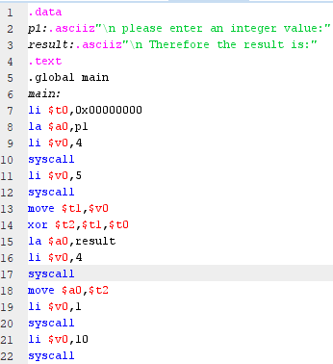

**EXECUTION:**

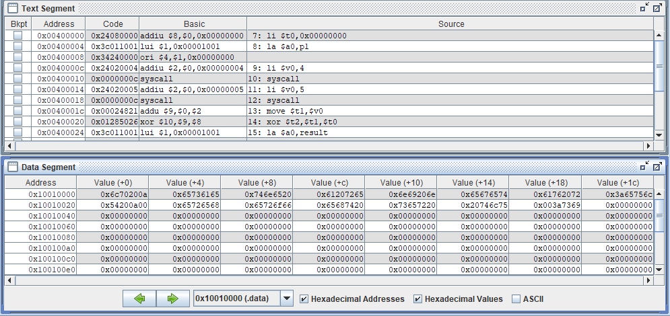

**OUTPUT:**

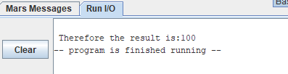

2. Show the result of following expression: 2 n , Where n is last digit of your Roll No

**CODE:**

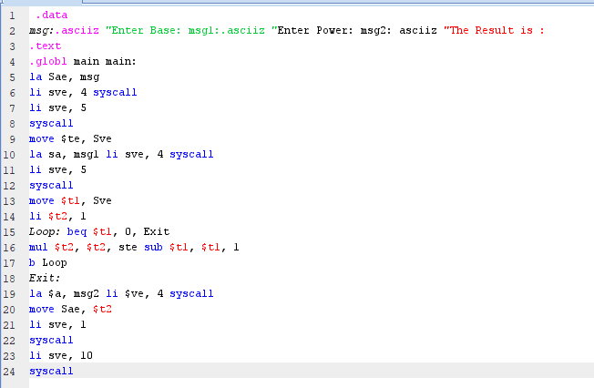

**OUTPUT:**

